Truven – Continuous Enrollment in SQL

* logic taken from Qi Feng, utilized within a macro to trim down a cohort
  + Male OAB project folder is: \rwi\projects\18_905\prod\

Steps

1. Pull cohort of interest at patient level
2. JOIN truven_commerical_claims_union.detail_enrollment_table to your current selection
3. SELECT dtstart, dtend from truven_commerical_claims_union.detail_enrollment_table and cast as timestamp

* this will give the start and end dates for each month a patient is enrolled. Qi mentioned that used the monthly enrollment indicator (0, 1) from annual_enrollment table would not be as thorough (some patients may end within month)  
  
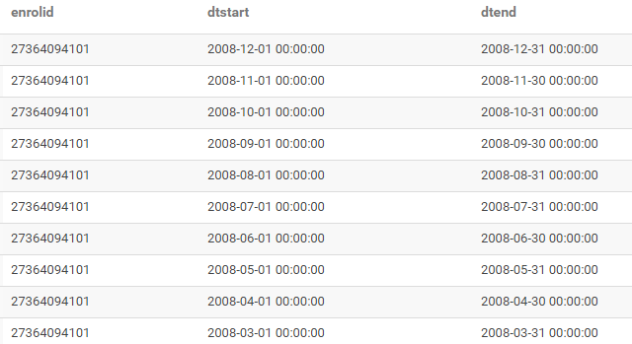

1. Then find the gap within each month, for the time period you are interested in.
2. You can then specify the max gap you are interested in new table formed.  
     
   *rows with 0 values are days with continuous enrollment

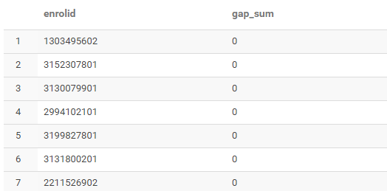

**Macro usage:**

**Description:** A function to identify gaps in enrollment.

**Usage:**

enrollment_gap(current_cohort='sandbox_truven.ac_gc_cohort4', start_date='2016-03-01', end_date='2018-09-01')

**Arguments:**

|  |  |
| --- | --- |
| *current_cohort* | String name of table from sandbox_grwi, which contains enrolids of patients of interest. |
| *year_start* | First year of enrollment gap check. |
| *year_end* | Last year of enrollment gap check. |

**Value:**

Final result will be one table with enrollment ids and sum of gaps.